# Name: Neha Sharma MID: M1040187

# 

# DOCKER IMAGES 201

Problem Statement:

Build a 2-tier java application. Write a Docker File for creating an image & containerize the application. Push the image to Docker hub, deploy it and get all the parts to work together.

Execution Steps:

For the ease of execution, I have pushed my JDBC Spring Boot application to GITHUB.

Account Creation:

Create a Docker account hub official site ([https://hub.docker.com/).](https://hub.docker.com/).The) The created account is used to create a repository and push the Docker Images. Now we must create a repository.

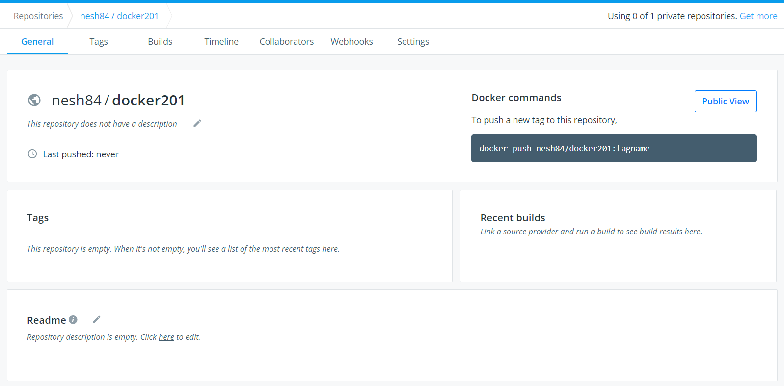

* Clone the application from GITHUB that has to be dockerized into the Cloud Lab VM.
* In order to do the first open Cloud Lab with given credentials.

Docker File:

Docker fie is a text document that contains all the commands which assemble to create Docker Image. We need to create a Docker File to containerize the application. Docker can build the images by reading instructions from Docker File.

Steps to Create a Docker File:

We need to create a directory first to store the spring boot jar file and “Dockerfile” and build image of the jar file through docker and the subsequently to docker container.

Commands: “**mkdir docker_201**” to create directory and type “**cd docker_201**”

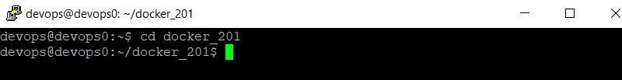

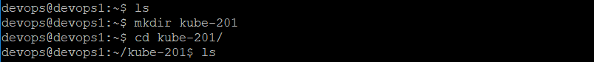

* Now create a docker File to write the configuration to build the image and then container.

Command: **“touch Dockerfile**”

We can see the content of the home directory with “**ls**” command.

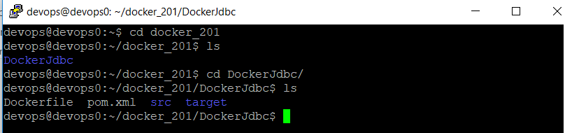

* To see/edit the contents of the “Dockerfile” the below command should be used.

Command: “vi Dockerfile”.

1. We have to add the below content in the Dockerfile.

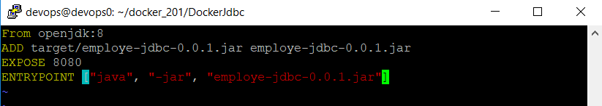

: wq is the command to save into the changes into the file.

Let us understand each command of the Dockerfile.

1. **FROM**: It is used to pull a public image from Docker-Hub and get that added to the build. In our case, it initializes an ubuntu instances with latest configuration.
2. **ADD:** It is used to copy new files, directories, or downloads from remote URLs.
3. **EXPOSE:** It ensures that the container that the application listens to specific port at runtime.
4. **ENTRYPOINT:** ENTRYPOINT allows you to configure a container that will run as executable.

**BUILDING THE DOCKER IMAGE USING DOCKERFILE**

Command: **sudo docker build -f Dockerfile -t jdbc-docker .**

Note: Here docker build is the command and -t jdbc-docker is the tag we are assigning to the image.

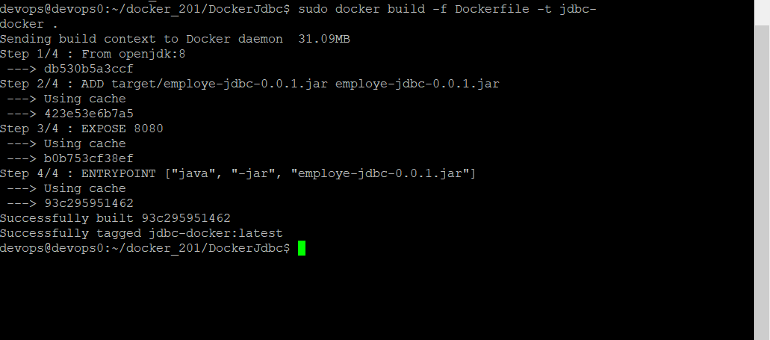

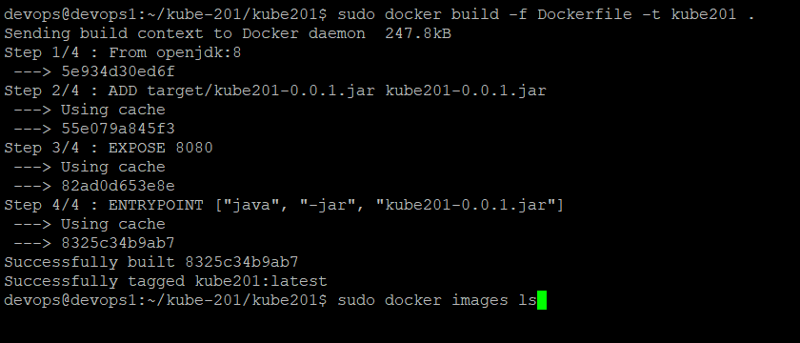

To check if the docker image is created properly we use the following:

Command: **sudo docker image ls**

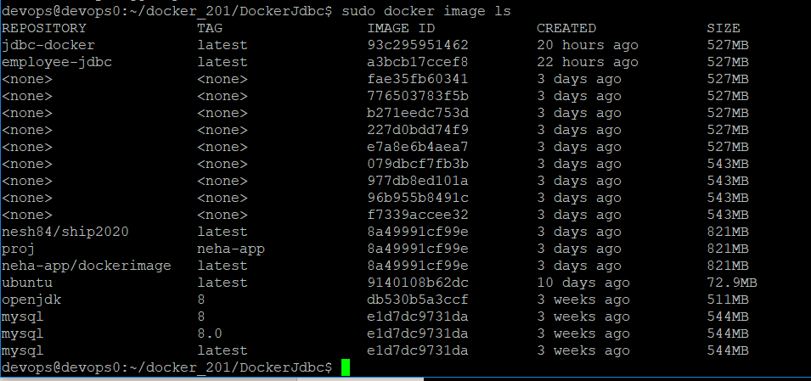

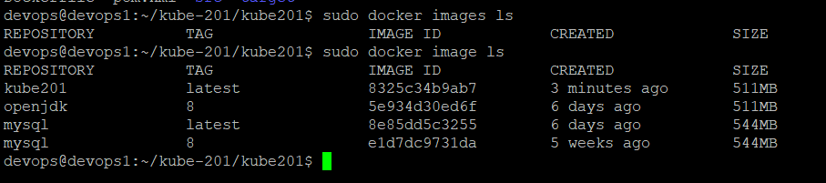

**Creating Container for Image**

Command: **sudo docker run -p 8080:8080 --name myjava-docker -d jdbc-docker**

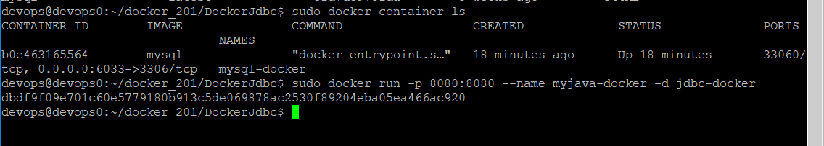

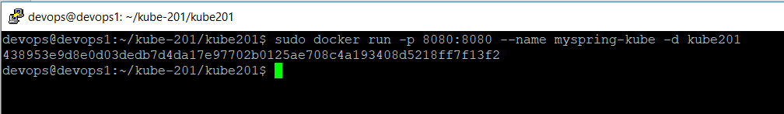3

Note: -name is the command to give the <any name> of the container and -d is to give command which image container need to be linked.

To check the container, which container is running: **sudo docker container ls**

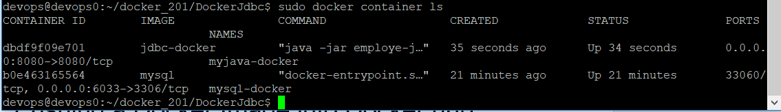

Pushing a Docker Image into Docker hub

Now that we have create our image the next step to push the data into our docker-hub. The command for pushing the image is given below.

Note: To push clone git code in docker hub you can either use below.

Command: **git clone** [**https://github.com/nesh84/DockerJdbc.git**](https://github.com/nesh84/DockerJdbc.git)

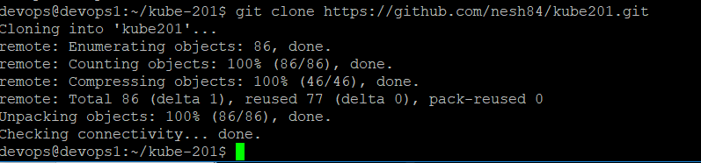

Command: **sudo docker tag jdbc-docker nesh84/dockerjdbc**

Command: **sudo docker push nesh84/dockerjdbc** (*name should be given in small letters*)

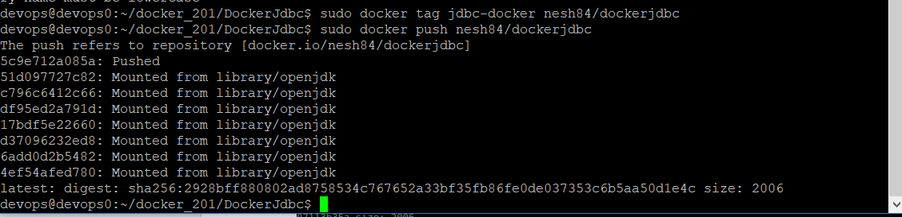

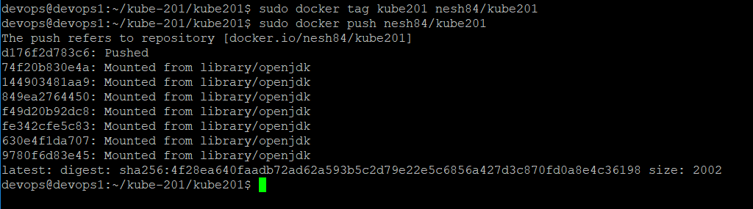

**RUNNING DOCKER-CONTAINER FOR MYSQL**

Note: Use this command if same name container issue appears:

**sudo docker rm mysql-docker**

Command**: sudo docker run -d -p 6033:3306 --name=mysql-docker --env="MYSQL_ROOT_PASSWORD=root" --env="MYSQL+PASSWORD=root" --env="MYSQL_DATABSE=bootdb" mysql**

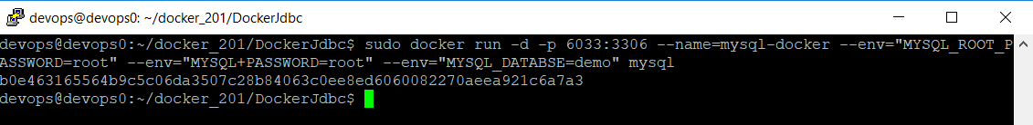

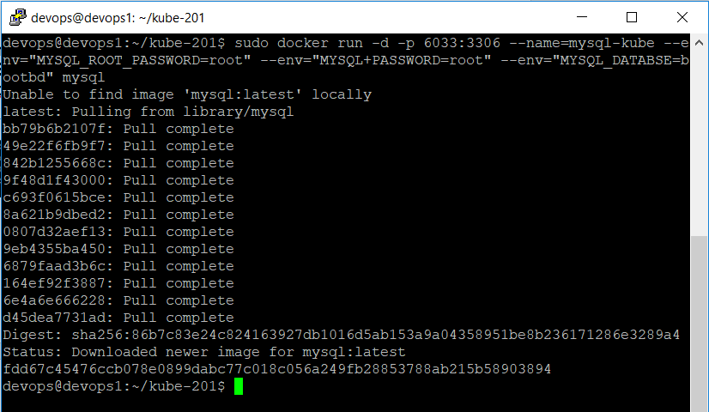

To see the container running in container:

Command: **sudo docker container ls**

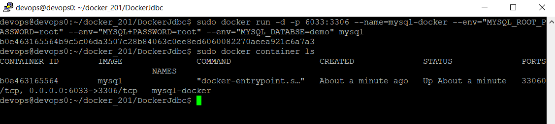

To check whether MySQL is running perfectly in docker container

Command: **sudo docker exec -it mysql-docker bash**

Command: **mysql -uroot -proot**





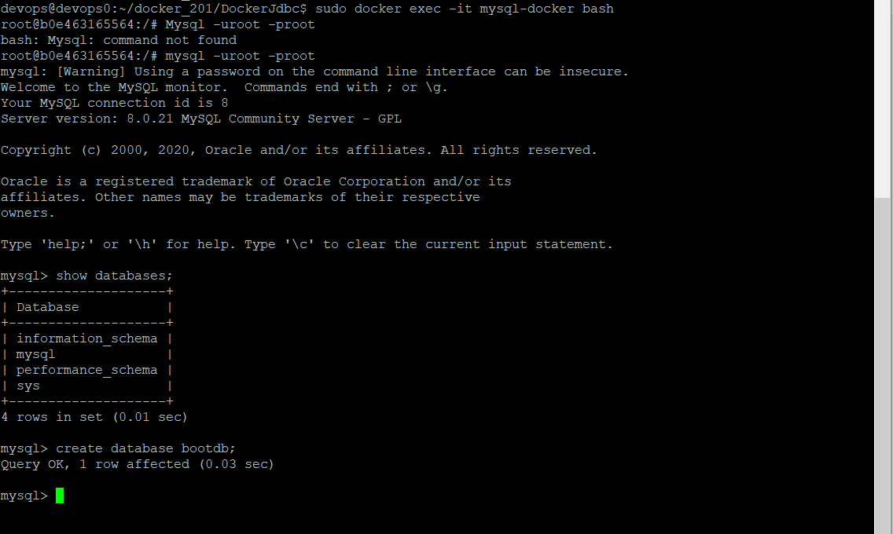

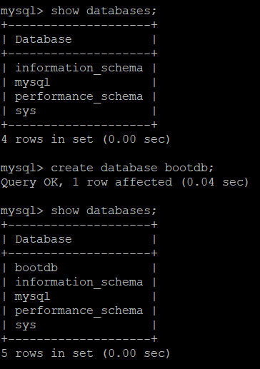

**RUNNING SPRINGBOOT WITH SQL CONTAINER**

Command: **sudo docker run -t --link mysql-docker:mysql -p 8081:8080 jdbc-docker**

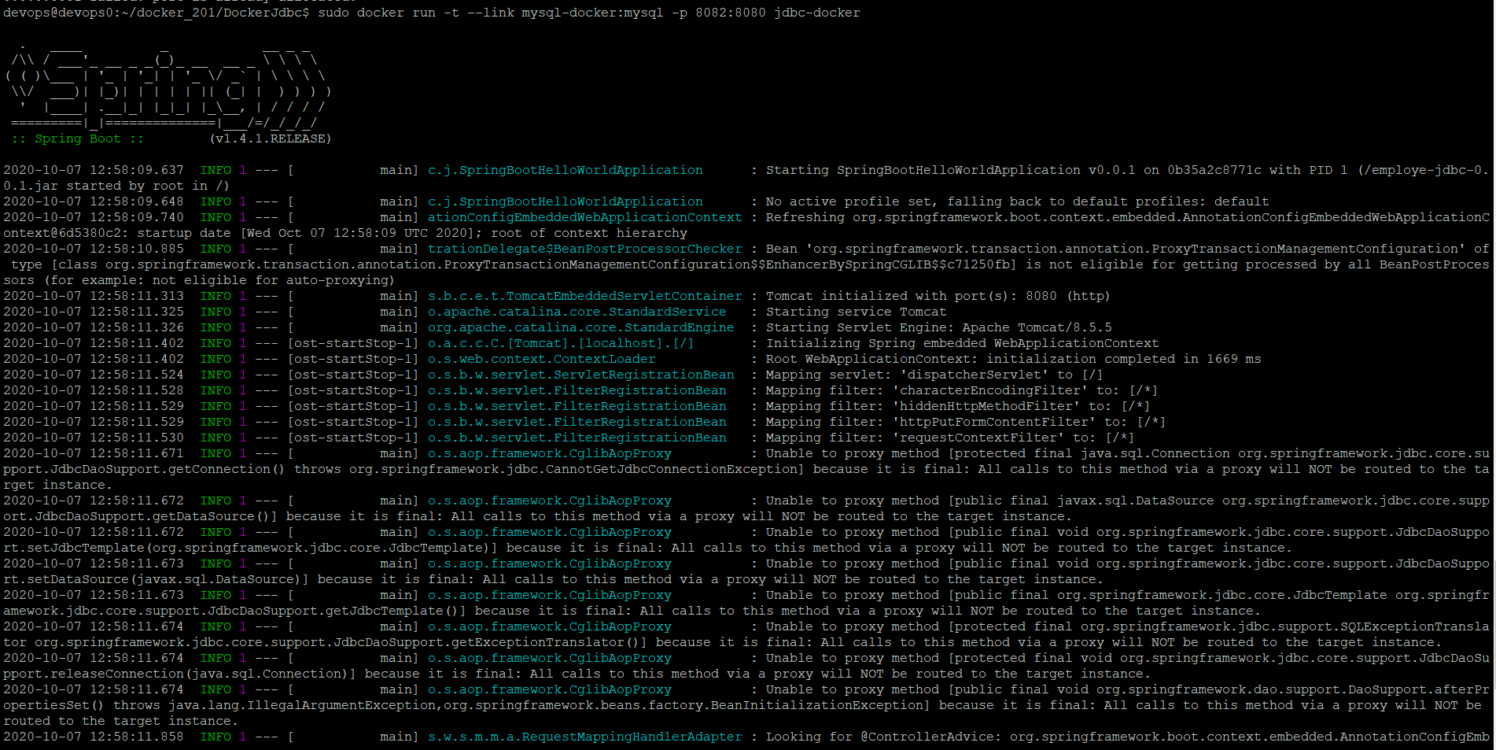

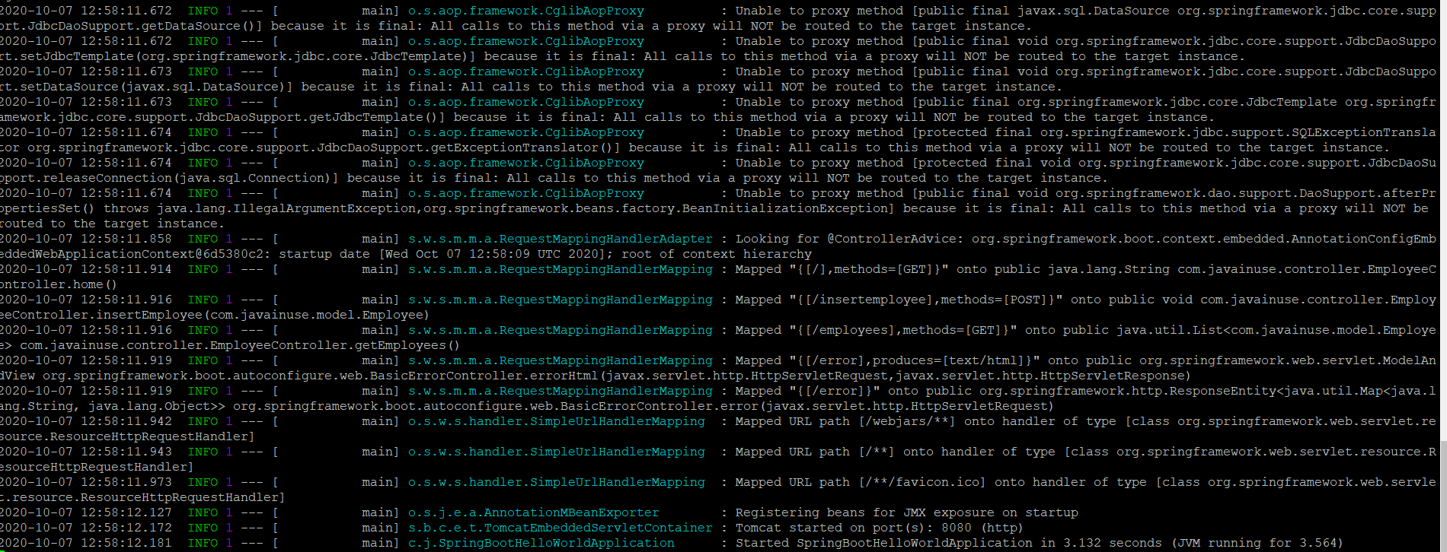

**Running SPRING BOOT && MYSQL with DockerCompose**

Now we must create a docker-compose.yml file by using below command.

Command: **touch docker-compose.yml**

To edit the docker-compose.yml, we use the below command.

Command: **vi docker-compose.yml**

We need to write the script in that file in order to run MySQL and spring boot application.

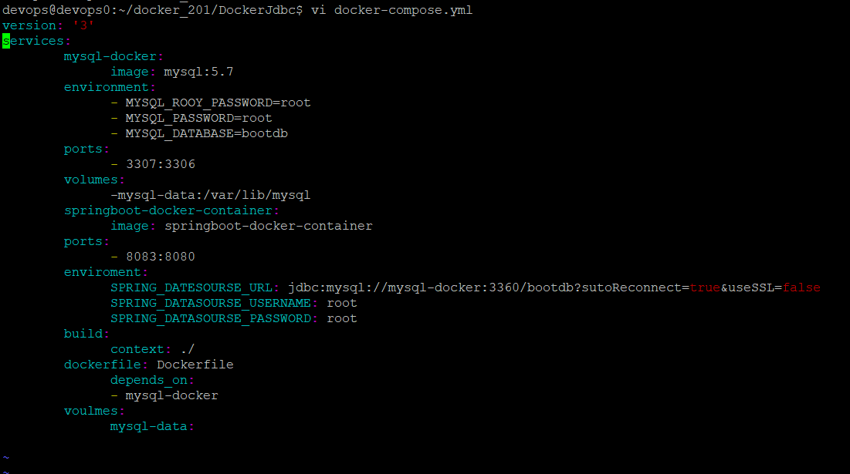

Command to make the container up: **sudo docker-compose up**

Command to make the container down: **sudo docker-compose down.**

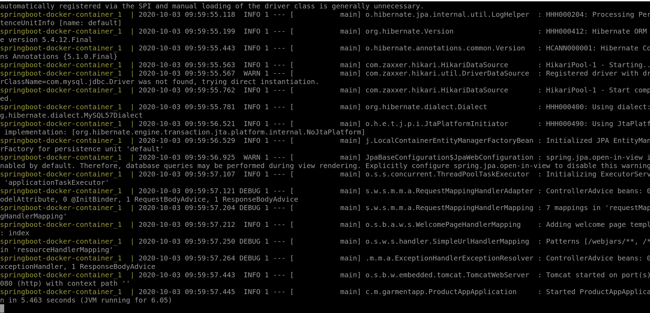

Now we can safely start the application.

But in order to we have to know the hostname in which the application can be started.

Command to know the command: **curl ifconfig.me**

IP Address: 104.46.113.165

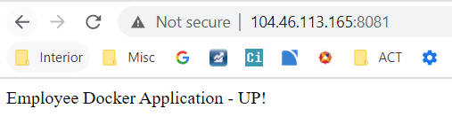

Add:

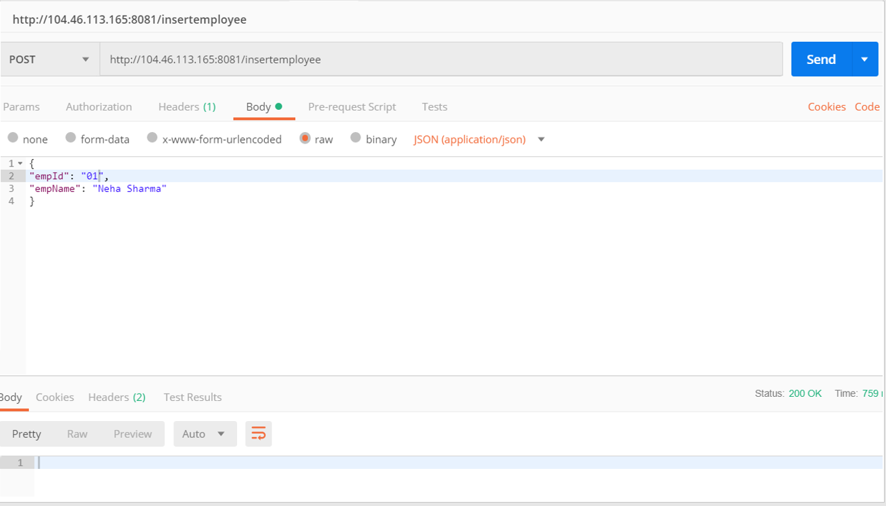

View:

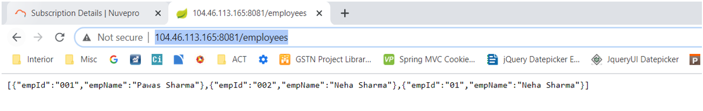

CodeCoverage:-

Sonar lint – review:

Customer junit:

Sonar -customer:

Great ☺